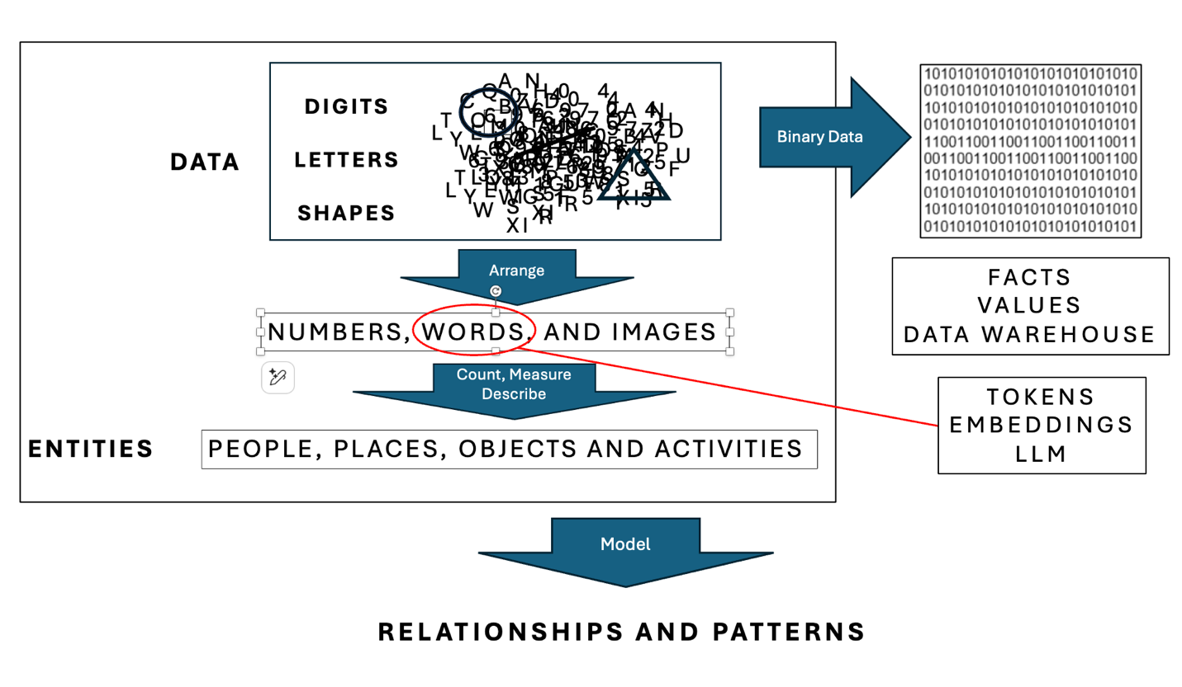
Digits are arranged to form numbers, the counts and measures used to quantify entities. Letters are arranged to form words, the description of entity qualities. Entities are people, places, objects and activities.

Numbers remain intact when stored in databases. Words are tokenized and tokens are assigned numbers when stored in Large Language Models (LLM).

Tokens have embedded descriptions, and statistical relationships extend from token pairs to patterns formed when multiple tokens are related. It is these embeddings, statistical relationships and patterns captured in a LLM, that forms the foundation for AI.

All of this becomes more complicated, when one considers digits and letters are stored as binary bits. So, it is easy to get lost in this ‘brew’ of bits, digits, letters, numbers, words, tokens relationships embeddings and entities.

Simply stated: Numbers are required to count and measure entities. Words are required to describe entity relationships and qualities. Everything is related! Numbers without words become meaningless. Words without numbers might be speculative. Quantitative Data Analysis is improved by the Qualitative Data Analysis produced by AI.

AI need not be the subject of fear and loathing. AI is teaching us ‘how to learn’ which is critica; when we don’t know the ‘what to learn’. I remind people that all data - every digit, letter and shape - are transformed into invisible and incomprehensible tiny bits of electricity or light. This digital data transformation is what caused us to become reliant on machines. Our machines have grown more intelligent, more capable of learning how to learn in our digitized world.
..

